LIS Housekeeping User’s Manual
School Representatives can assign Class Advisers to a class.
- Login Page
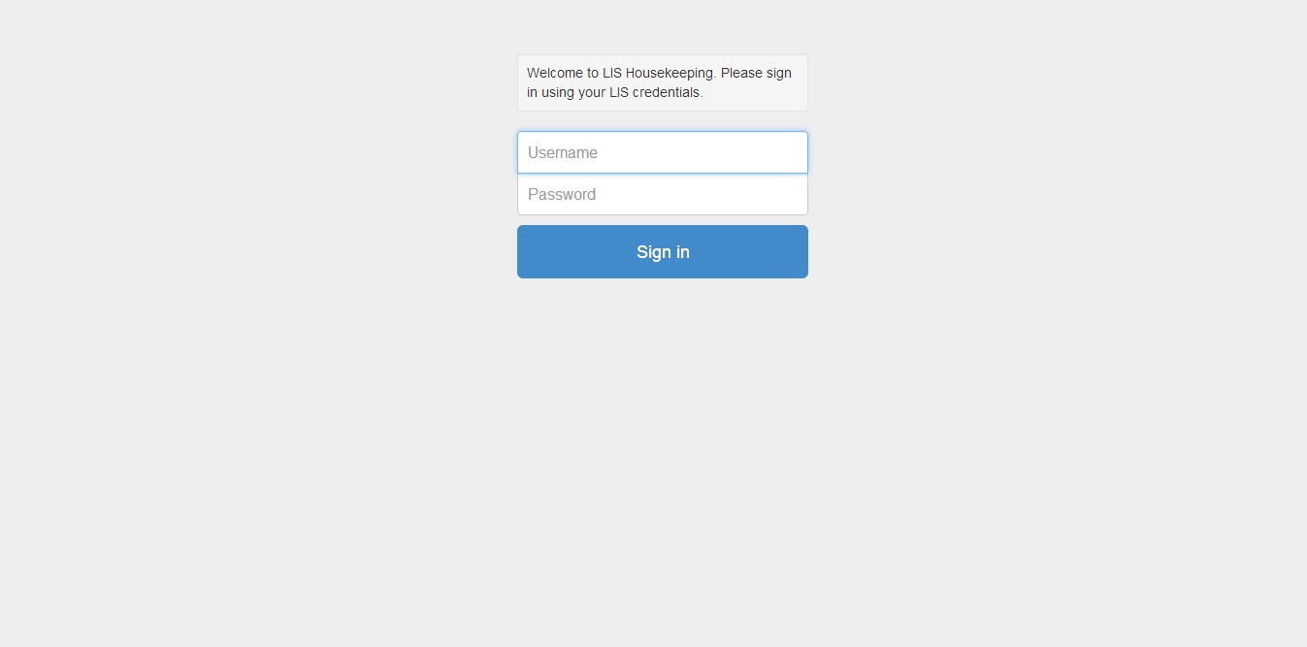
[Action Steps] – How to log into the LIS Housekeeping Application (Assigning Class Advisers)
- Enter your School Representative username and password on the screen shown above, and then click the ‘Sign In’ button.
- Wait for the system to process your credentials.
- A successful login will bring you to the LIS Initial Application Page (Item # 2)

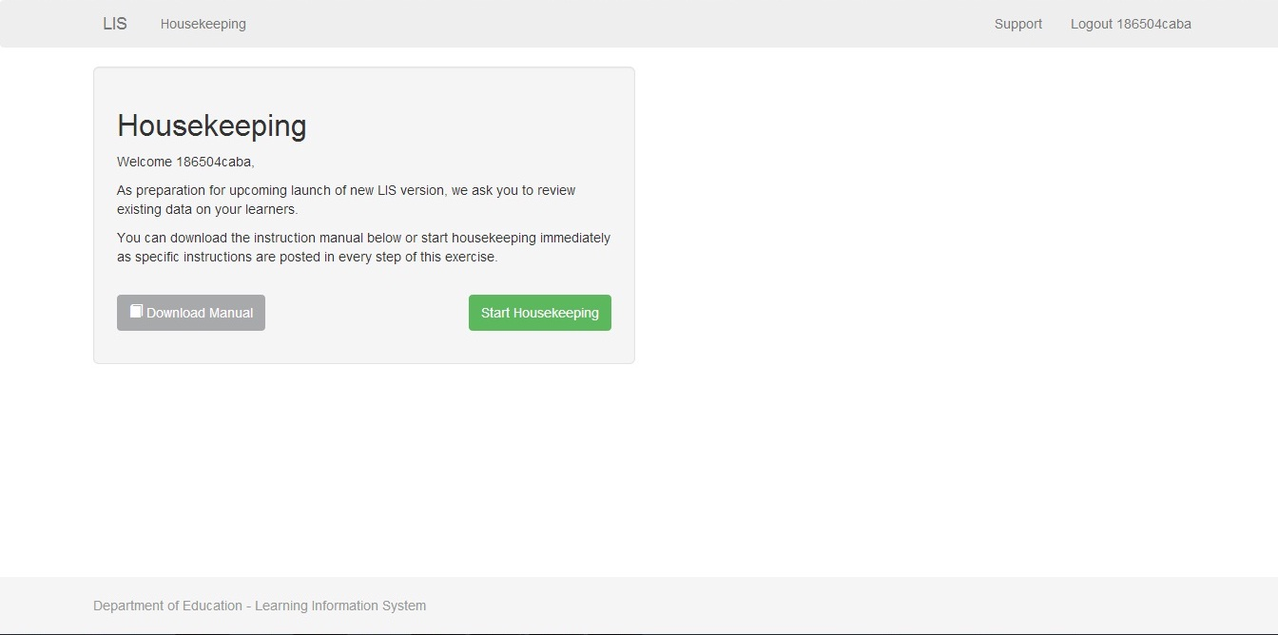
[Action Steps] – How to start assigning Class Adviser to a class.
- Click Start Housekeeping

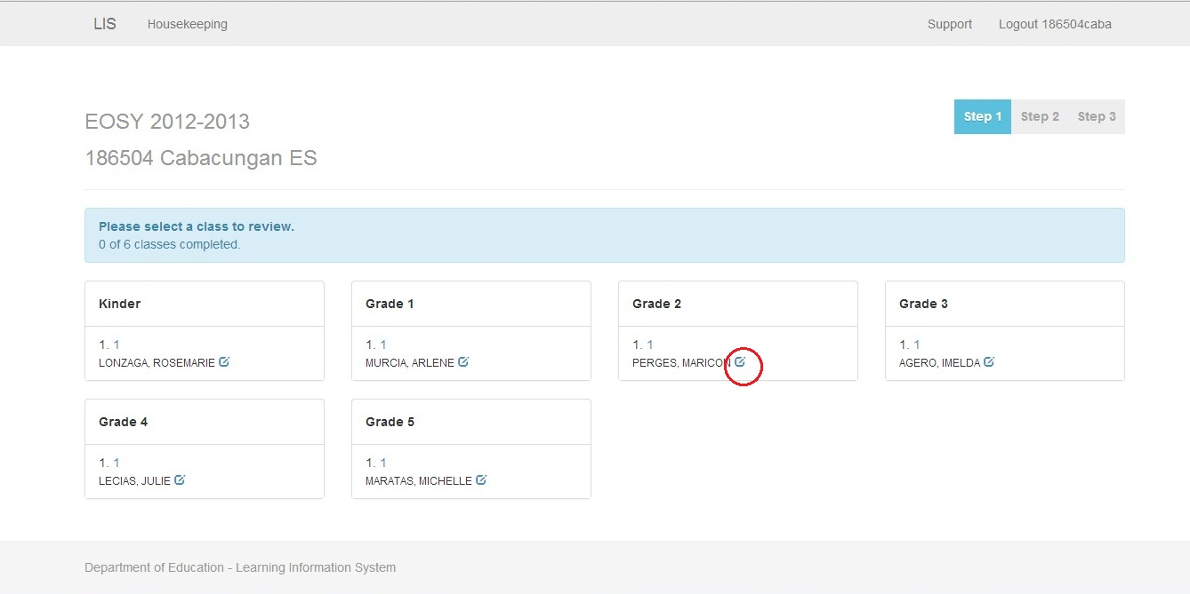
[Action Steps] – Start Assigning Class Advisers.
- Click the edit button on the side of the Class Adviser.
- Proceed to Item # 4.

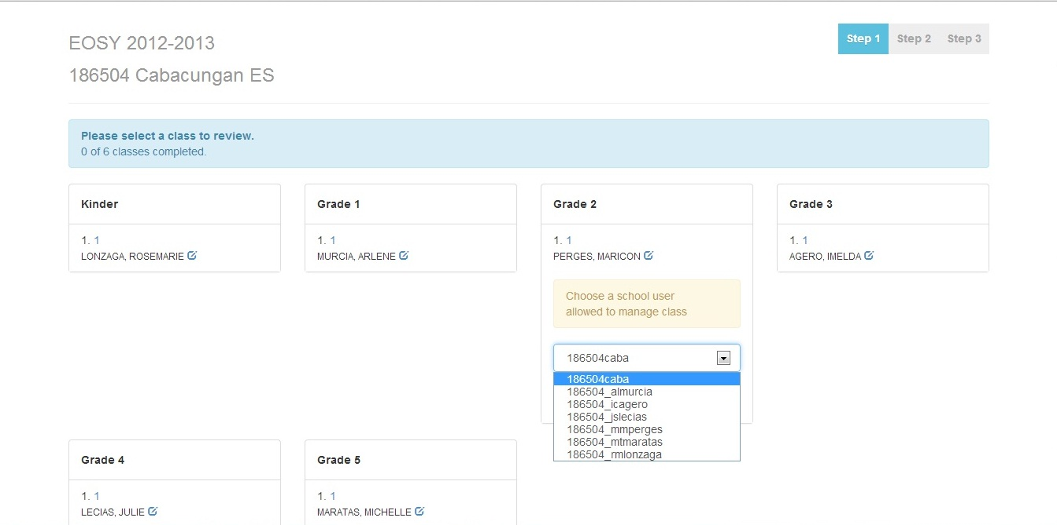
[Action Steps] – Assign a Class Adviser.
- Choose the correct class adviser username on the dropdown that correspond on the
class adviser name or username indicated.
- Proceed to item #5.

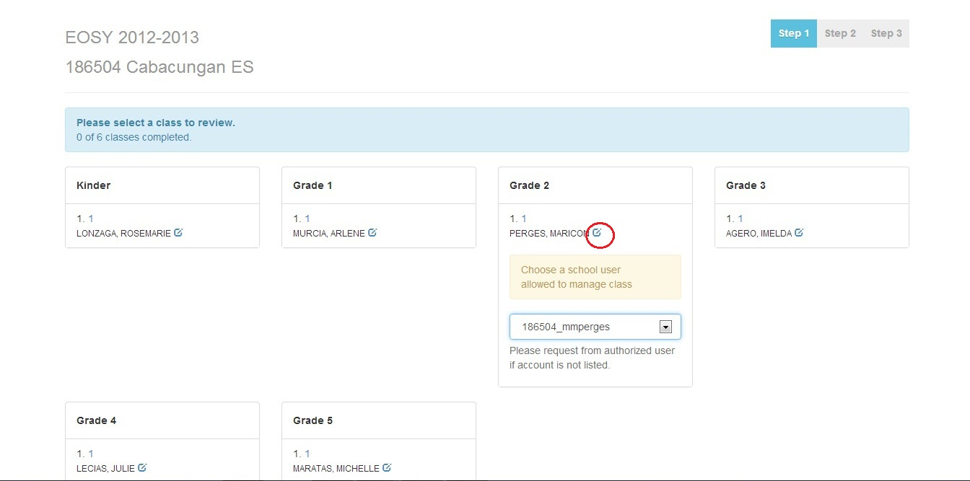
[Action Steps] – Save Class Adviser Choosen.
- Click the edit button to save the chosen class adviser.
- Proceed to Item # 6.

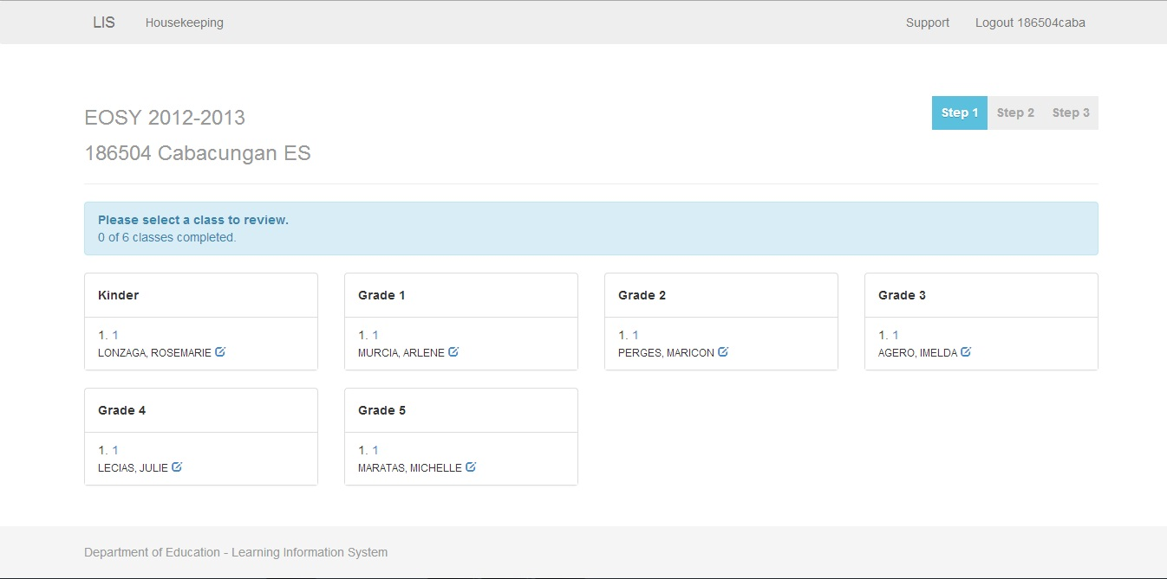
[Action Steps] – Finish.
- After assigning class advisers to the available classes you are now finish.
- Click the Logout button.
- Have the class adviser login to the housekeeping site – the learners should appear, if not the learner class has no define section. Another housekeeping module is being prepared for this.

