LIS Housekeeping User’s Manual
The following are steps on how to use the LIS Housekeeping Application to review and update/add learner’s data for SY 2012-2013 (Formal Schools)
- Login Page
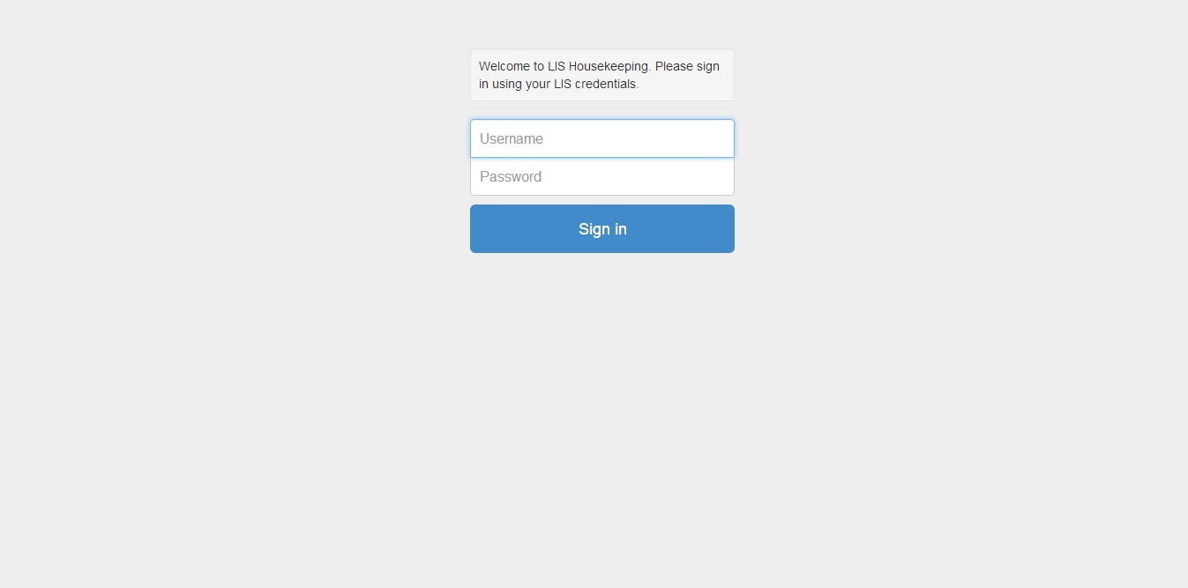
[Action Steps] – How to log into the LIS Housekeeping Application
- Enter your LIS username and password on the screen shown above, and then click the ‘Sign In’ button.
- Wait for the system to process your credentials.
- A successful login will bring you to the LIS Initial Application Page (Item # 2- A)

- LIS Initial Application Page - A
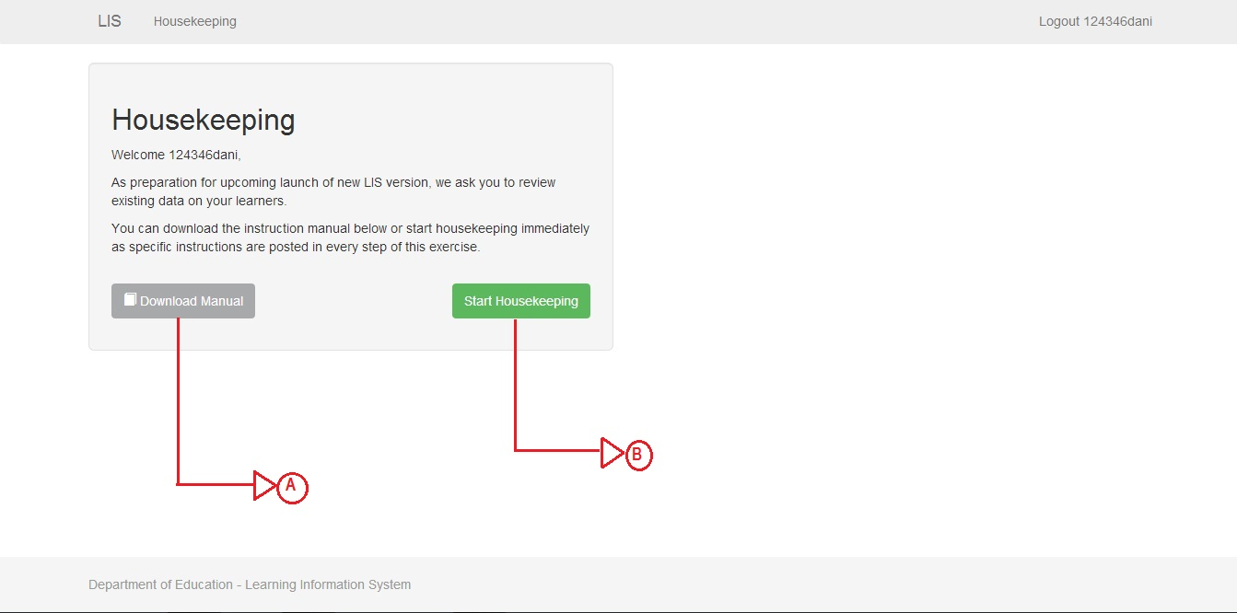
[Action Steps] – How to start housekeeping or review the user’s manual.
- Download the procedure manual to review the tasks associated with data housekeeping (this manual).
- Start LIS data housekeeping - (Begin – Proceed to Item # 3).

- LIS Initial Application Page
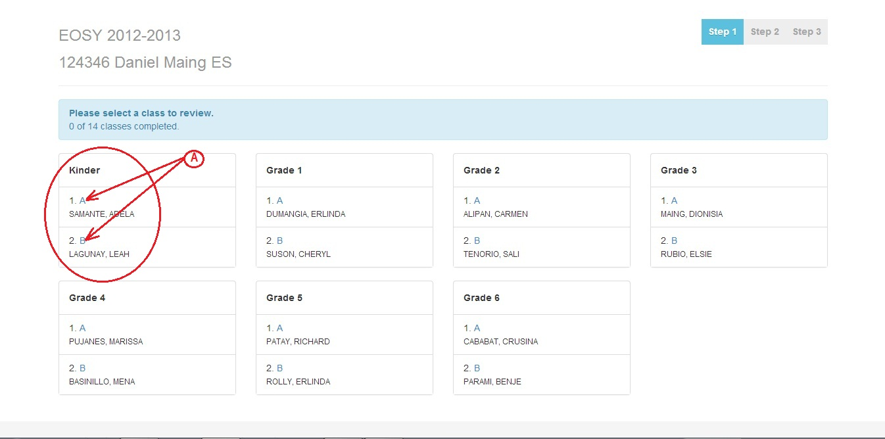
[Action Steps] – How to choose the Grade/Year Level, Section and Adviser.
The LIS Initial Application Page will show you the School Name/ID and the end of School Year that the housekeeping task will be applied to – in this case SY 2012-2013.
A table listing of Grade/Year Level, Class Sections and Advisers are presented to choose from. A Step indicator is highlighted at the far right corner of the screen to indicate at where you are in the data housekeeping tasks.

- Click the highlighted section to proceed to the class listing.
- Proceed to Item # 4.

- LIS Initial Application Page
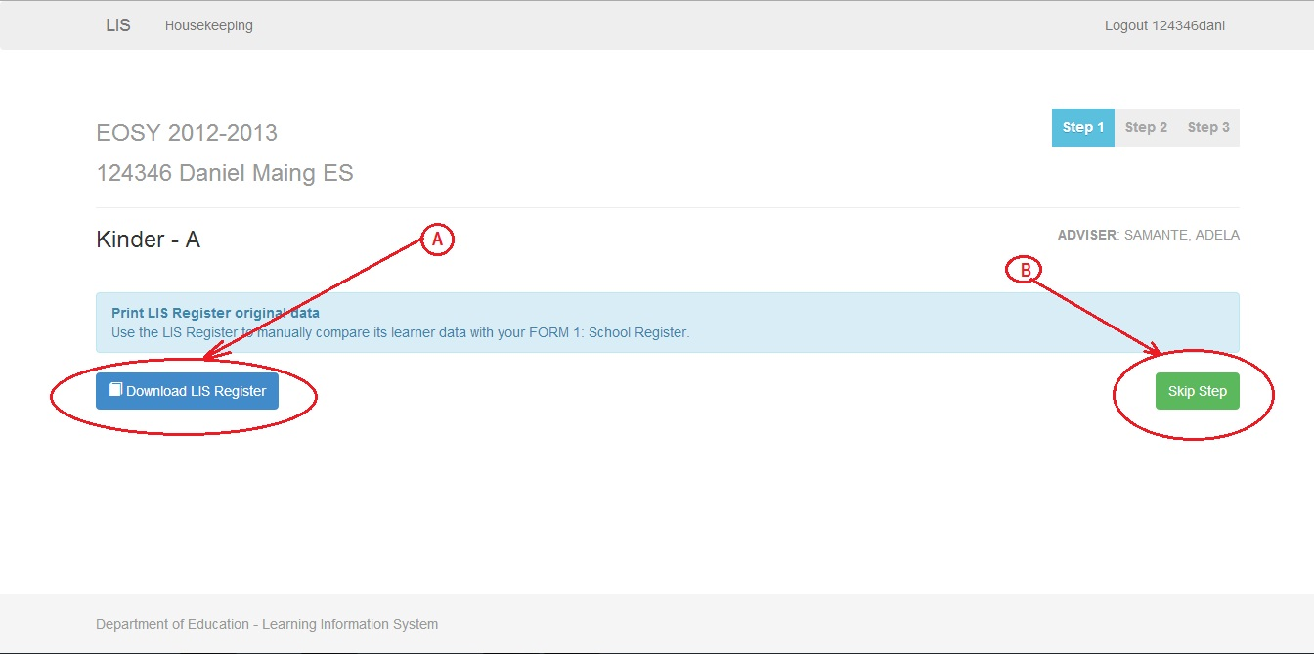
[Action Steps] – How to download the LIS Register.
- Click the Download LIS Register button to download the LIS Register containing uncorrected data to compare with the School Register (Form 1).
- Click the Skip Step button to skip the page.
- Proceed to the next task (Item # 5)
- LIS Housekeeping Main Page
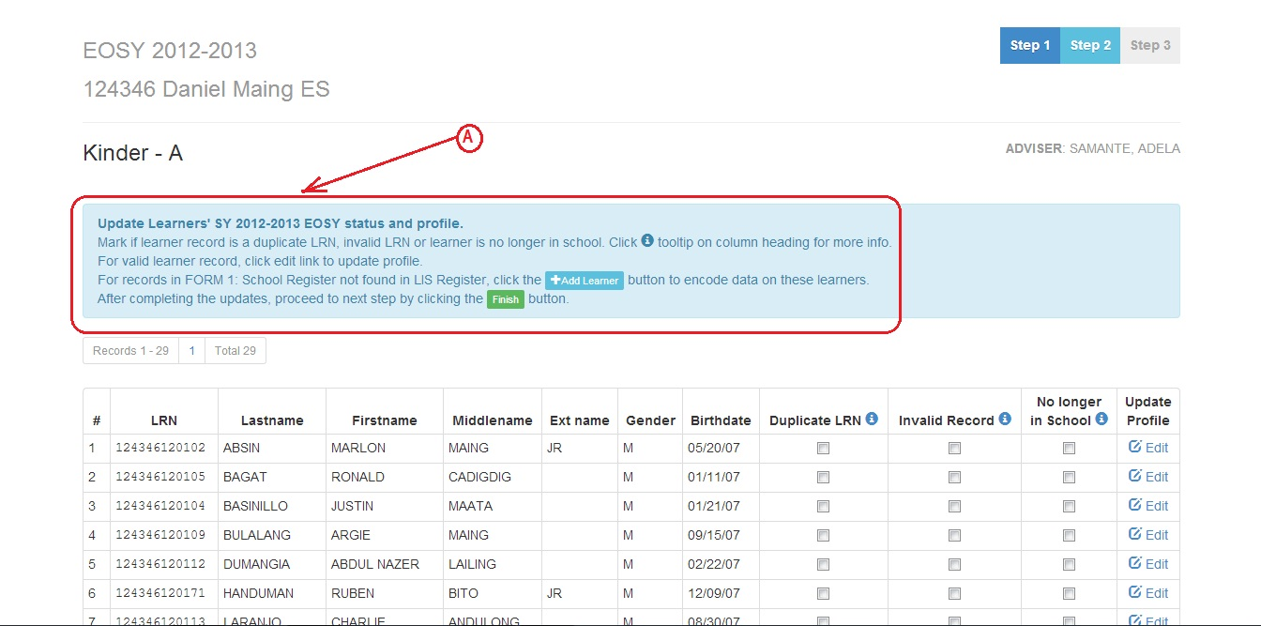
[Action Steps] – How to review and update the chosen list of learners’ data.
- Follow the instructions located on top of the data listing as shown above
- Proceed to the following task items depending on your review of the learner’s data:
  - If the learner LRN is a duplicate proceed to task Item # 6.
  - If the learner LRN is invalid proceed to task Item # 7.
  - If the learner is no longer in school proceed to task Item # 8.
  - If the learner data is valid proceed to task Item # 9.
  - For learner data not found in the LIS Registry but is present in the School Register (Form 1) proceed to task Item # 11.
- If there are no more learner data to review and update, click the ‘here’ word to download/print the updated LIS Registry.
- Click ‘Logout’ to get out of the application.

- LIS Housekeeping Main Page
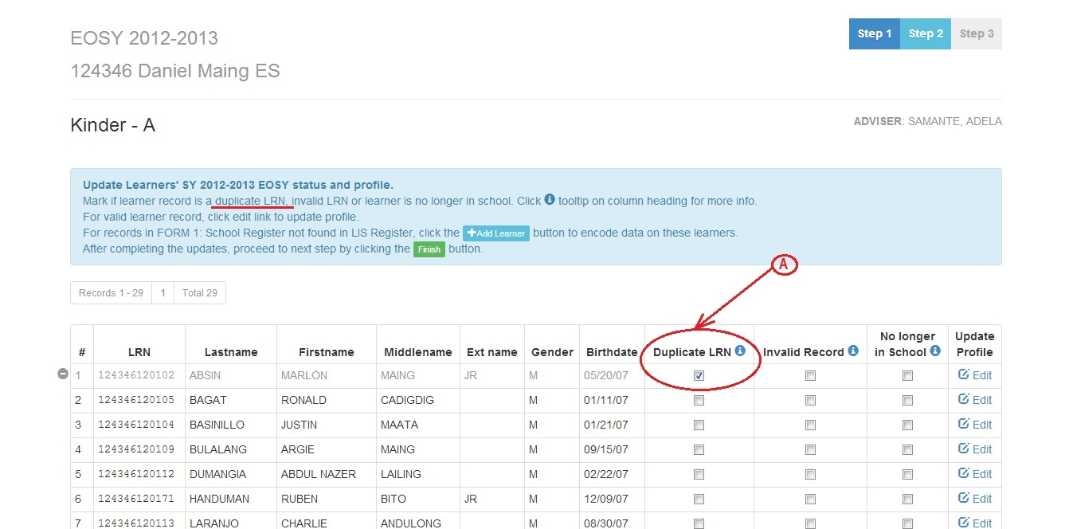
[Action Steps] - How to tag learner’s LRN as a duplicate.
- Click the button under the ‘Duplicate LRN’ column if upon verification of the learner’s LRN is not valid one but is only a duplicate of valid LRN reviewed previously, this will tag it as a Duplicate LRN.
- Click the info icon for more information.
- Proceed to Item # 5 Action Step B (For the next learner data).

- LIS Housekeeping Main Page
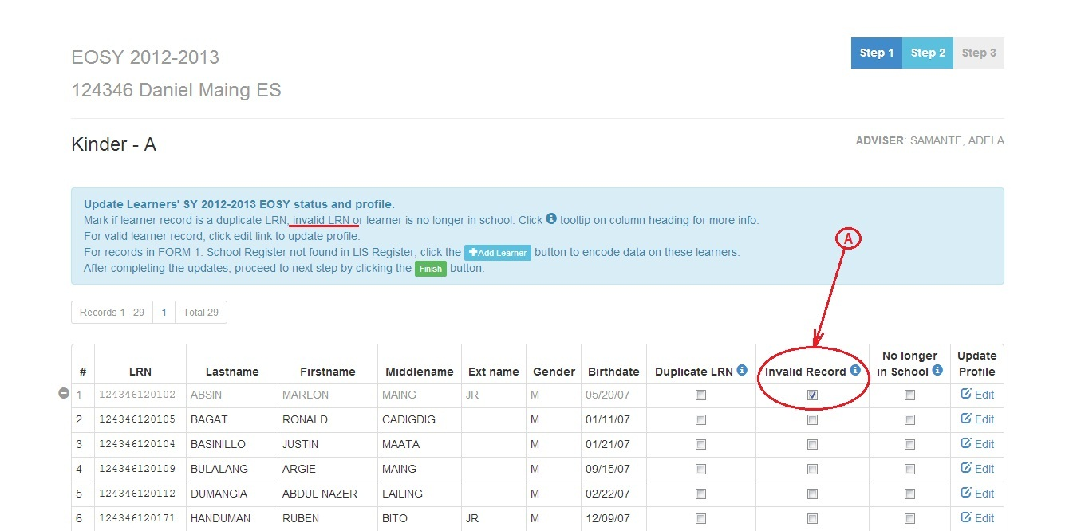
[Action Steps] – How to tag learner’s LRN as Invalid.
- Click the button under the ‘Invalid Record’ column if upon verification the learner LRN is not included in the school’s register, this will tag it as an Invalid Record.
- Click the info icon for more information.
- Proceed to Item # 5 Action Step B (For the next learner data).

- LIS Housekeeping Main Page
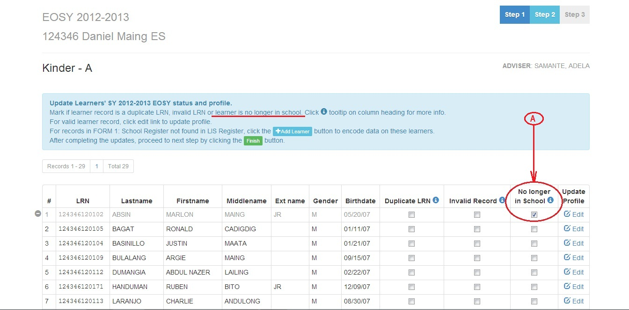
[Action Steps] – How to tag if the learner is no longer in school.
- Click the button under the ‘No longer in School’ column if upon verification the learner has dropped out of school or transferred to another school.
- Click the info icon for more information.
- Proceed to Item # 5 Action Step B (For the next learner data).

- LIS Housekeeping Main Page
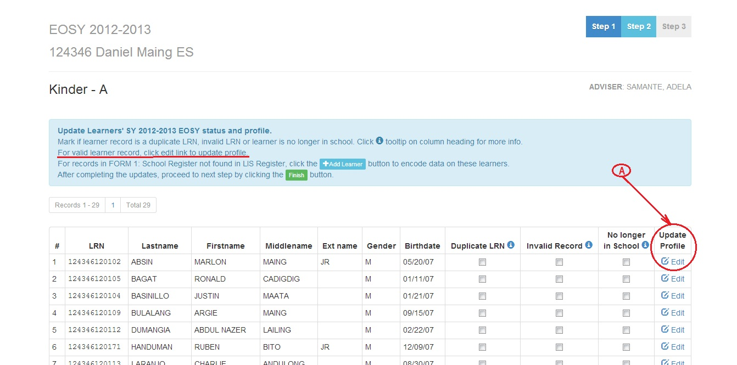
[Action Steps] – How to update a valid learner data.
- Click the ‘Edit ‘link to update learner’s current profile as shown above.
- After clicking the ‘Edit’ button the application will bring you to the LIS Housekeeping Edit Page (Item # 13).

- LIS Housekeeping Edit Page
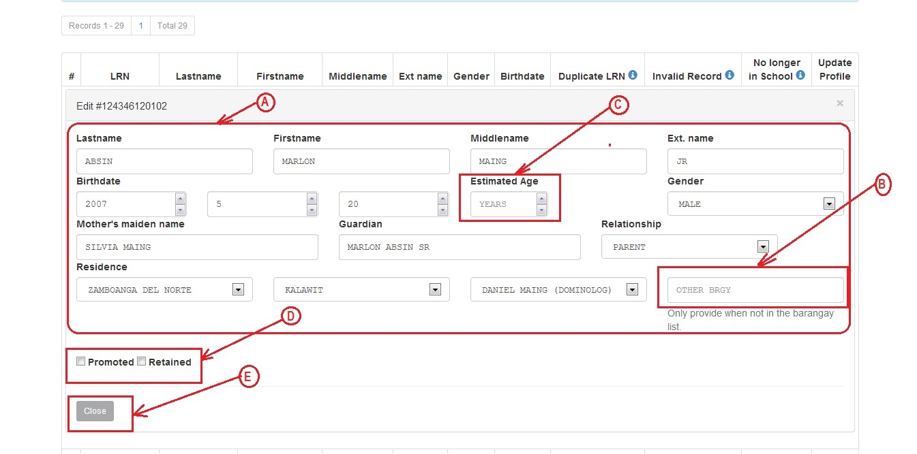
[Action Steps] – How to update a learner profile.
- Edit and update the learner’s data as needed – do not leave any item blank.
- Enter the barangay name in the ‘OTHER BRGY’ field if it is not listed in the ‘Barangay’ list – this will add the new barangay name. (Please note if you enter a new barangay in the ‘Other Brgy’ field the ‘Barangay’ list will momentarily be deactivated while you are updating).
- Enter the estimated age on the ‘or Estimated Age’ field - if you cannot provide an exact date based on the birth certificate or any other documentation. (Please note if you enter the estimated age on the ‘or Estimated Age’ field the ‘Birthdate’ fields will momentarily be deactivated while you are updating).
- After completing your updates on the learner data proceed to the following tasks depending on the status of the learner :
  - Click the ‘Promoted’ button if the learner is promoted to the next Grade/Year level then click the ‘Save’ button before proceeding to task Item E.
  - Click the ‘Retained’ button if the learner is retained to the present Grade/Year level then click the ‘Save’ button before proceeding to task Item E.
- Click the ‘Close’ button to leave the Edit Page.

Add a learner data to the present class – a learner data which is not on the LIS Registry but is present on the School Register (FROM 1) can be added by following the steps below.
- LIS Housekeeping Main Page
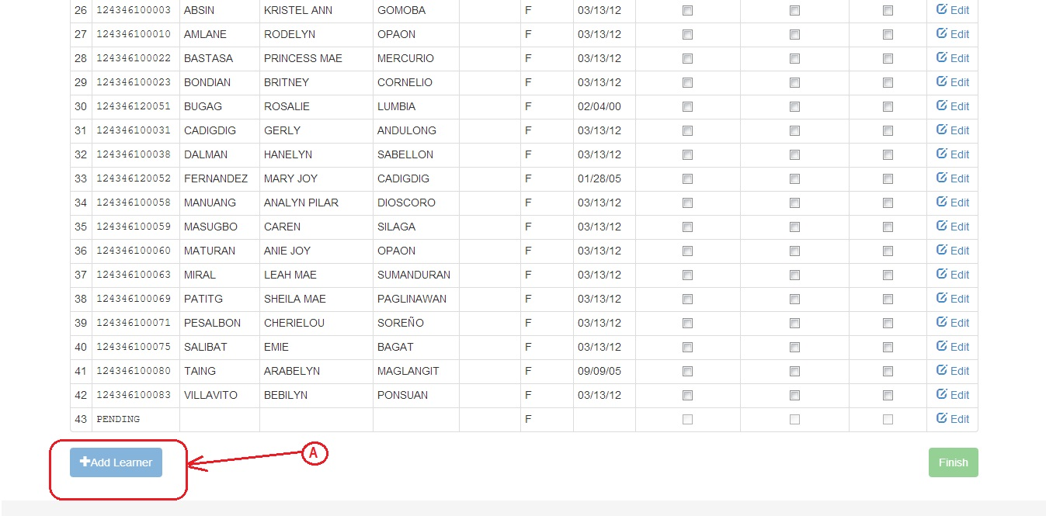
[Action Steps] – How to add a learner to the class.
- Click the ‘+Add Learner’ button to add a learner to the class.
- After clicking the ‘+Add Learner to Class’ button this will bring you to the LIS New Learner Page (Task Item # 12).

- LIS Housekeeping Add a Learner Page
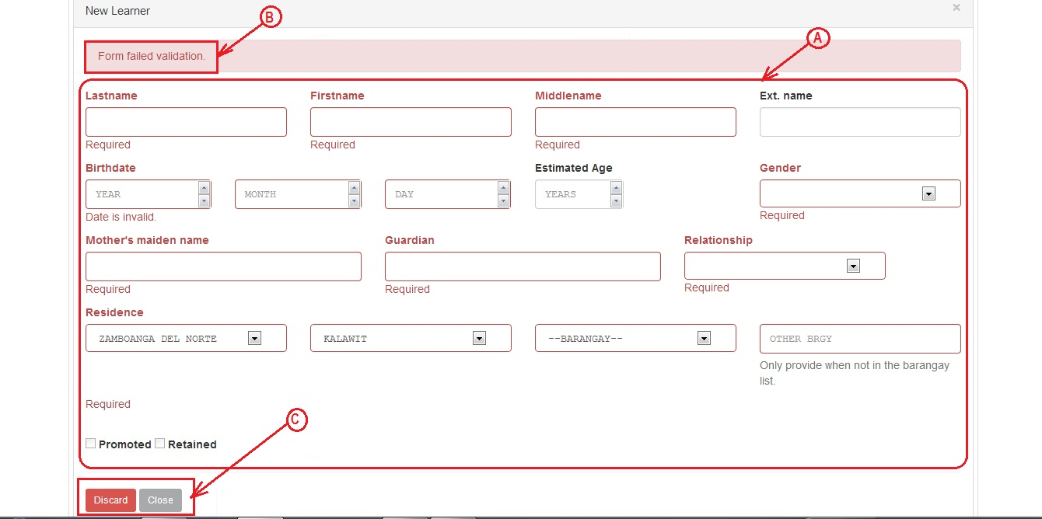
[Action Steps] – How to add a learner to the class.
- Furnish all learner information and do not leave an item blank.
- The ‘Form failed validation message will appear if a required field is left blank.
- Click the Close button to save and exit the ‘Add New Learner Page’ or the Discard button to discard the added learner.

