LIS Facilitator Housekeeping User’s Manual
The following are steps on how to use the LIS Facilitator Housekeeping Application to review and update Facilitator information for SY 2012-2013 (ALS)
- Login Page
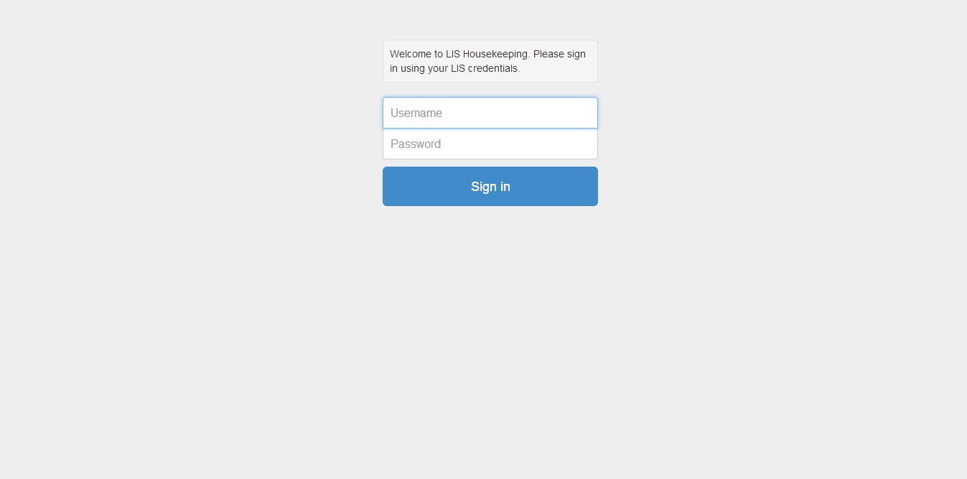
[Action Steps] – How to log into the LIS Housekeeping Application
- Enter your LIS username and password on the screen shown above, and then click the ‘Sign In’ button.
- Wait for the system to process your credentials.
- A successful login will bring you to the LIS Facilitator Housekeeping Initial Screen (Item # 2)

- LIS Facilitator Housekeeping Initial Screen
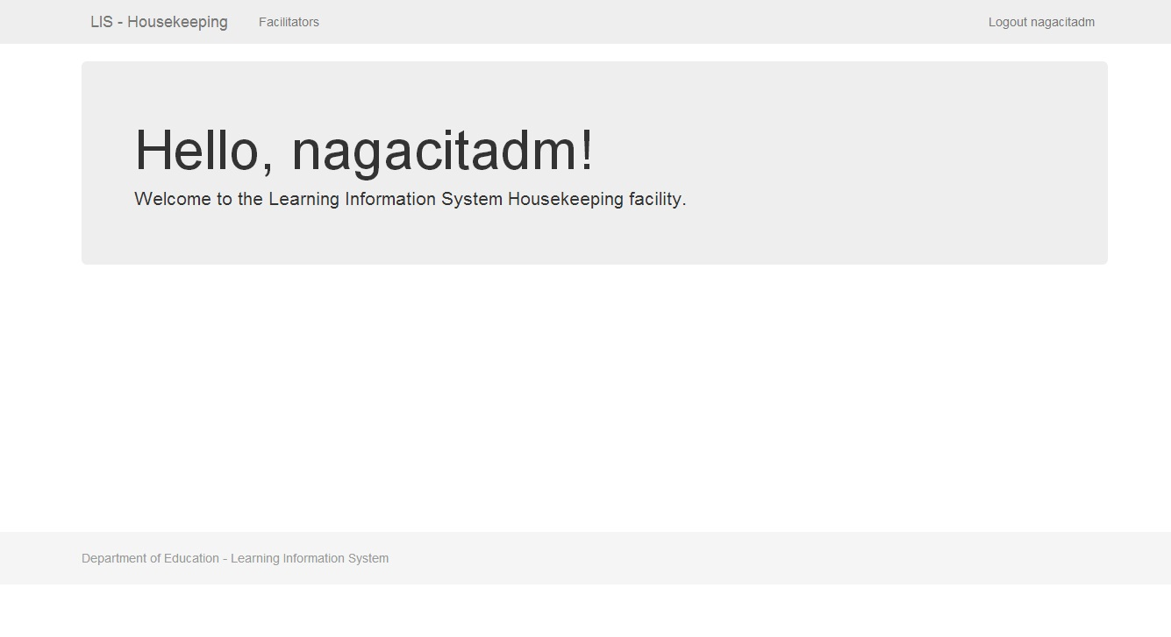
The LIS Facilitator Housekeeping Initial Screen will show the Name of the user who logged in. Click the menu item on top labelled ‘Facilitators’ to proceed to Item # 3.

- LIS Facilitator Housekeeping Application Page
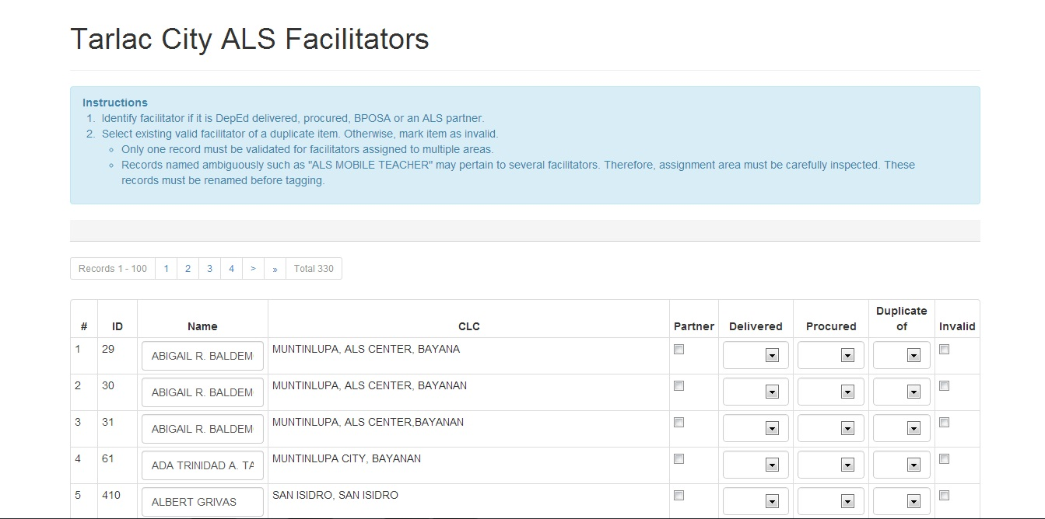
[Action Steps] – Identify Facilitator if it is of the following:
- Click the button on the right side labelled “Partner” if the facilitator being reviewed is one. Proceed to the next task (Item # 4)
- Click the button on the right side labelled “Delivered” if the facilitator being reviewed is one. Two choices will appear :
  - MT – Mobile Teacher
  - DALSC - District ALS Coordinator
- Proceed to the next task (Item # 5)
- Click the button on the right side labelled “Procured” if the facilitator being reviewed is one. The following choices will appear :
  - LSCS – Literacy Service Contracting Scheme for Basic Literacy Program
  - LSDS – Learning Support Delivery System for A& E Program
  - LV – Literacy Volunteer
  - BPOSA – Balik Paaralan Para Sa Out of School Adults
- Proceed to the next task (Item # 6)

- LIS Facilitator Housekeeping Application Page
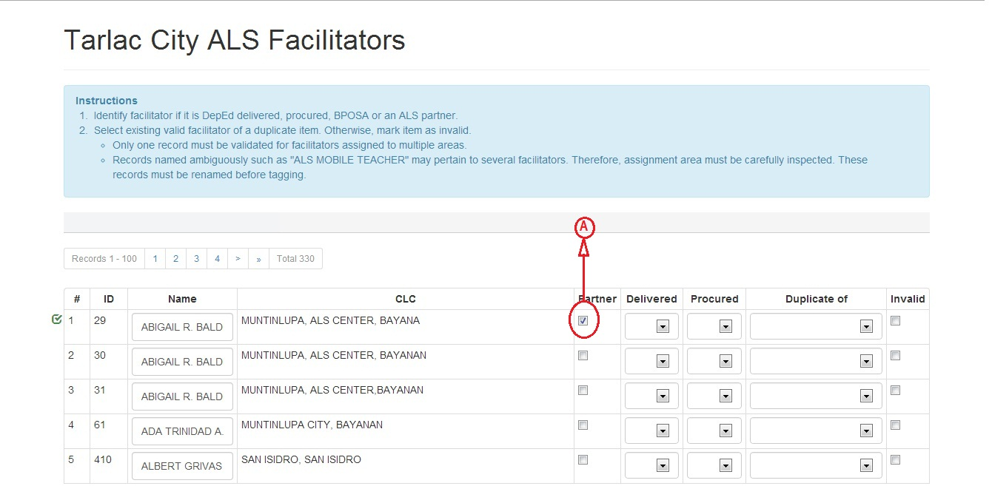
[Action Steps] – How to define if a Facilitator is a Partner.
- Click the button under “Partner” and a check will appear to confirm the type.
- Proceed to Item # 7 for the next row item.

- LIS Facilitator Housekeeping Application Page
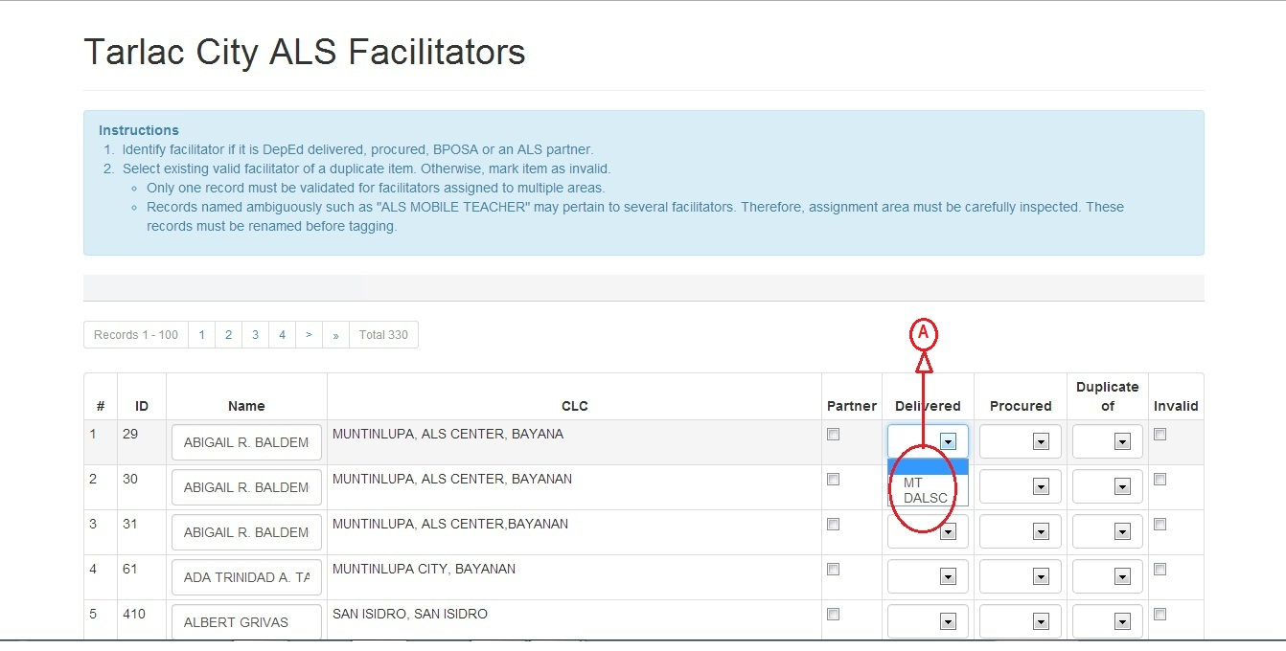
[Action Steps] – How to define the type of a “Delivered Facilitator”.
- Click the item labelled “MT” if the Facilitator being reviewed is a Mobile Teacher or Click the item labelled “DALSC” if the Facilitator being reviewed is a District ALS Coordinator.
- Proceed to Item # 7 for the next row item.

- LIS Facilitator Housekeeping Application Page
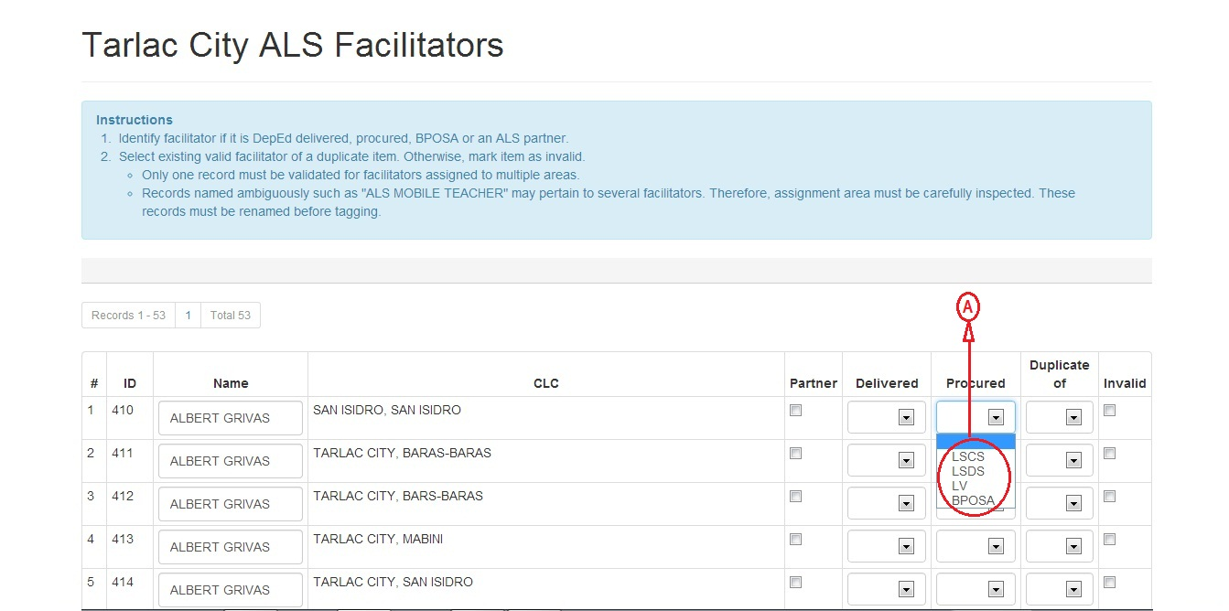
[Action Steps] – How to define the type of a “Procured Facilitator”.
- Choose from the following :
  - LSCS – If the Facilitator is under the Literacy Service Contracting Scheme for Basic Literacy Program
  - LSDS – If the Facilitator is under the Learning Support Delivery System for A& E Program
  - LV – If the Facilitator is a Literacy Volunteer
  - BPOSA – If the Facilitator is under the Balik Paaralan Para Sa Out of School Adults
- Proceed to Item # 7 for the next row item.

- LIS Facilitator Housekeeping Application Page
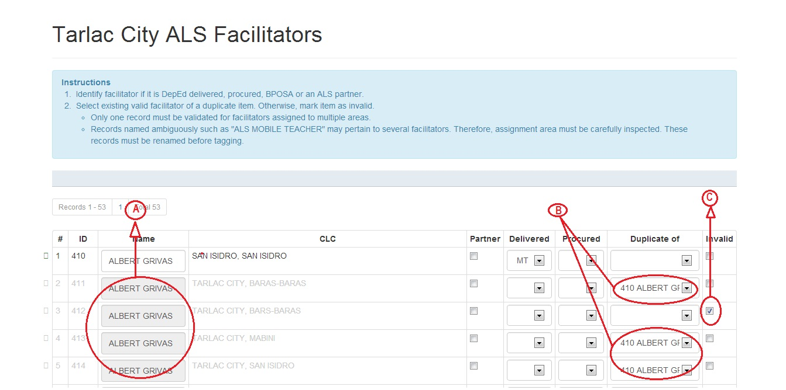
[Action Steps] – How to identify it if it is a duplicate or invalid entry from the previous row.
- If the Facilitator Name is the same as that of the above row proceed to step B, if not proceed to Item # 3.
- Click the dropdown list under the label “Duplicate” and choose the ID and Name of the preceding Facilitator data.
- If the row data is invalid click the button labelled “Invalid” at the far right corner.
- If the next row’s Facilitator Name is not the same as those of the preceding ones proceed to Item # 3 else keep to item # 7.

- LIS Facilitator Housekeeping Application Page
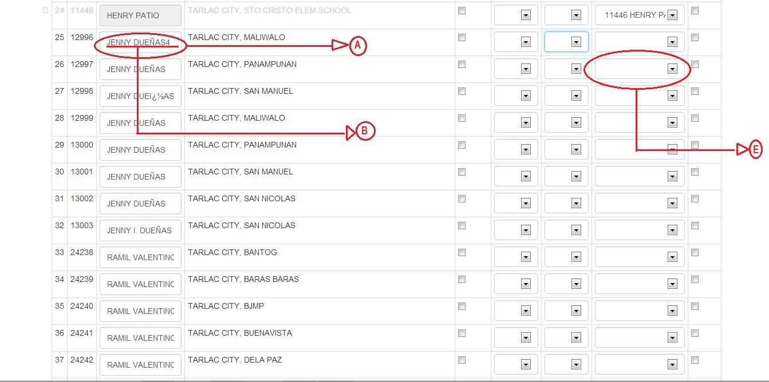
[Action Steps] – How to edit Facilitator Name when there are numbers and special characters embedded in the Name text field.
- Click the Name text field that will be edited as shown above – it will highlight briefly before the text field is ready for editing.
- Enter the correct Facilitator Name.
- If you need to identify the Facilitator type proceed to Item # 3.
- If you need to tag the Facilitator data as duplicate or invalid proceed to Item #7.
- No need to update the Name text field below the row if it’s a duplicate – just relate it via the duplicate dropdown list.

- LIS Facilitator Housekeeping Application Page
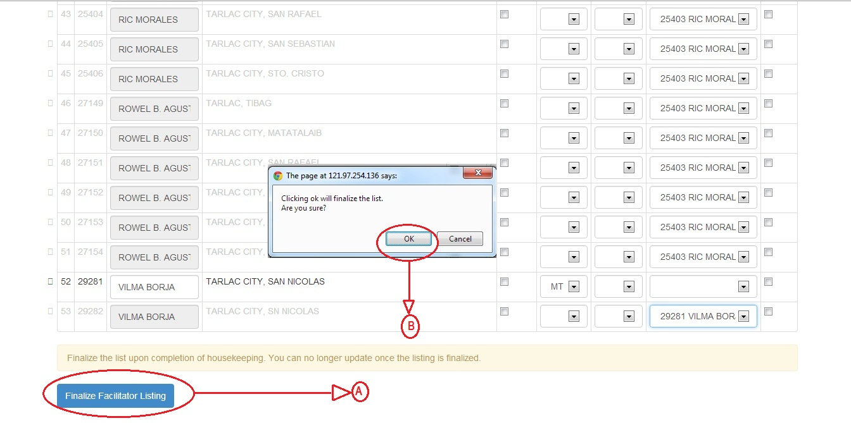
[Action Steps] – Finalize Facilitator Listing
- Click the button labelled “Finalize Facilitator Listing” to finalize the list.
- A confirmation message will appear as shown above – Click OK to confirm.
- End of Facilitator Data review and update.

